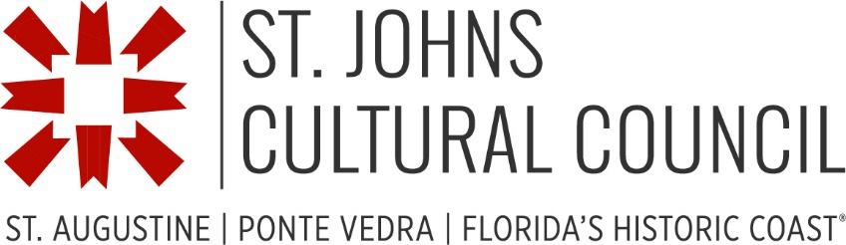

Facilities Manager
Part-time
Position Summary
The St. Johns Cultural Council (SJCC) is seeking a part-time Facilities Manager, reporting to the Executive Director. The Facilities Manager will oversee maintenance, leasing activities, and events of two National Register-listed historic venues, The Cultural Arts Center at The St. Augustine Beach Hotel and the St. Augustine Waterworks.
Responsibilities include:
- Daily communication with tenants, cultural organizations, and members of the public
- Responding to inquiries about use of The Waterworks and Cultural Arts Center
- Preparing rental agreements, invoices, and collecting venue fees.
- Support for SJCC and other events, including planning, set-up, and staffing the events
- Scheduling cleaning, landscaping and maintenance services
- Updating and renewing leases
- Providing monthly reports on rental activities and events
- Regular availability on evenings and weekends
- Supervision of staff providing support at events

Qualifications
- 5+ years of administrative and supervisory experience
- 3+ years of event planning experience
- Demonstrated interest or background in arts, culture and heritage
- Effective communicator with good interpersonal skills
- Self-motivated with strong time management skills
- Must value completing work with attention to detail
- Comfortable working both independently and collaborating with team members as required
- Ability to maintain focus in an open-office environment
Compensation
The position is part-time, approximately 20 hours per week. Compensation range is $30 - $35 per hour, commensurate with experience. This part-time position does not include employee benefits but may include some paid holidays, depending upon agreed work schedule.
Hours and Location
This position is based at SJCC’s office in St. Augustine, Florida and will include periodic travel to a second facility in St. Augustine Beach. SJCC’s published office hours are 10 am to 5:00 pm Tuesday through Thursday and 10 am to 3:00 pm on Friday. Our facilities include community event spaces, with frequent evening and weekend hours. In addition, our staff attends and provides support for occasional off-site events. A willingness and ability to work at weekday evening and Saturday and Sunday events is required.
Equal Opportunity Employment
This position may require remaining stationary and using a computer for prolonged periods of time. It also requires lifting and moving items that may weigh up to fifty pounds. The noise level in the work environment is usually moderate. SJCC is committed to providing reasonable accommodations that enable people with disabilities to enjoy equal benefits and privileges of employment as are enjoyed by others. If you are contacted for an interview and would like to request an accommodation for that date, please send an email to admin@historiccoastculture.com.
SJCC is an equal opportunity employer, and does not discriminate on the basis of race, ethnicity, religion, creed, sexual identity, sexual orientation, national origin, ancestry, age, marital status, citizenship status, veteran status, disability or any other criterion specified by federal, state, or local laws, in the administration of its employment policy.
To Apply
Please email cover letter and resume, with the subject line “Facilities Manager” to admin@historiccoastculture.com.
This position is open until filled, but preference will be given to candidates who apply on or before June 15, 2023. We regret we are unable to respond individually to each applicant. We are only able to respond to candidates being considered for interviews.

