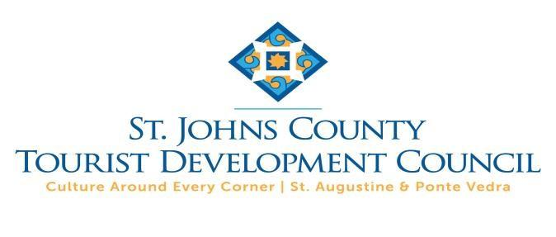
FINAL REPORT AND REQUEST FOR FINAL PAYMENT
ST. JOHNS COUNTY TOURIST DEVELOPMENT COUNCIL
FISCAL YEAR 2021 ARTS, CULTURE & HERITAGE FUNDING PROGRAM

This Final Report must accompany your request for final payment and
must be submitted within sixty (60) days after completion of your event/program, but in no case after October 10th, whichever occurs first.

SJCTDC Agreement Number:
Program Title:
Organization:
Name of person completing this form:
Email address:
Telephone number:

PART I: PROGRAM DESCRIPTION AND EVALUATION

- Please list the venues where and dates on which this Program was presented.

- Were the dates or venues different than what was included in your funding proposal? If so, please explain and attach documentation of your notification to the TDC of the changes in dates or venues. Please include any additions to or deletions from your proposed Program.

- Please provide a detailed written description of the activities included in the Program.

- How many people attended the Program? How many of these traveled from out-of-county?

- How was attendance calculated?

- Describe the success of the Program based on these TDC goals:

  - Generating incremental overnight stays in paid accommodations.

  - Generating incremental economic activity (visitor spending) within St. Johns County.

  - Development of high quality, authentic Arts, Culture and Heritage Tourism Programs recognized by the media, peer review and industry and visitor commentary.

  - Artistic and organizational capacity that enhances the competitive position of the St.
Johns County Arts, Culture and Heritage industry in relation to comparable destinations.

- How do you evaluate the quality of your program and measure your success? What changes do you plan to make to improve the quality and success of the Program in the future?

- Provide any documentation you have from accommodations and other partners regarding room nights or visitor expenditures generated by the Program.

- Provide copies of any printed promotional materials for which payment will be reimbursed with TDC dollars. Include screen shots of any online promotional materials for which you expect TDC reimbursement. YOU MUST INCLUDE DOCUMENTATION OF THE USE OF APPROVED TDC LOGO.

- Did your organization sell advertising space or include provided advertising space to sponsors in any of the materials you have presented to the TDC office for payment using TDC funds? If so, please provide sponsorship amounts and describe benefits received by the sponsors.

PART II: FINANCIAL REPORT

Complete the Spreadsheet found at https://stjohnsculture.com/grants-awards/tdc-grants
to report actual revenues and expenses for your Program. Attach the Spreadsheet to this Final Report.
Provide copies of invoices and paid receipts for expenses for which you are requesting reimbursement, as well as to document your match. Separate invoices and paid receipts by category: required advertising expense; additional expenses to be reimbursed with TDC funds; and required match.
Please note: if your unreimbursed event costs were greater than the required match, you do NOT have to provide documentation of the excess costs. To simplify reporting, we suggest that when documenting your match, you document fewer, larger expenses: for example, it is easier to document and review four $5,000 expense items than twenty $1,000 expense items!

PART III: REIMBURSEMENT REQUEST AND CERTIFICATION

[EVENT/ORGANIZATION NAME) has submitted its Final Report for the FY2021 [EVENT/PROGRAM(S)] completed on [COMPLETION DATE] and requests reimbursement of $ [AMOUNT]. The undersigned individual certifies, on behalf of the organization, that all of the information contained in this final report is true and correct.

Sigh Here )
Print Name:
Print Title:

Requested media from marketing campaign

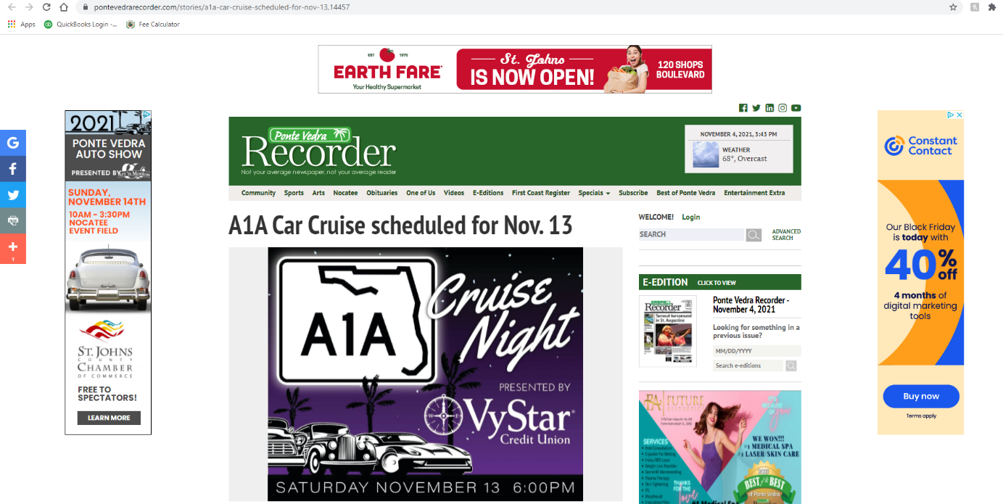
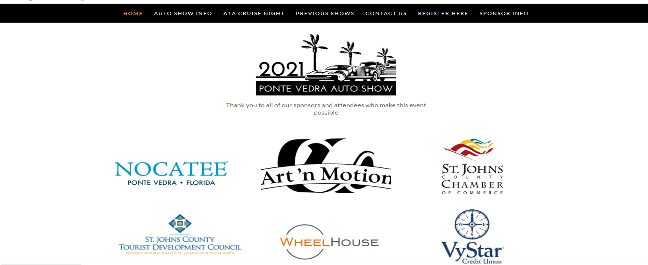
Online sidebar ad screenshot
Ponte Vedra Auto Show website homepage

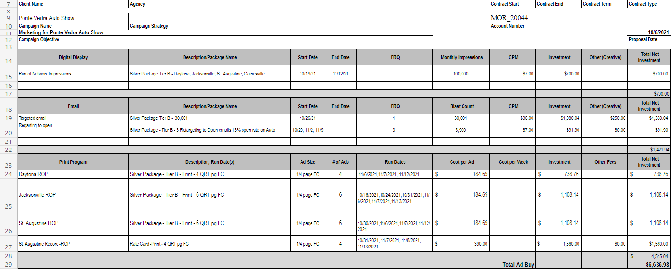
¼ page color print ad and digital version ran in Ponte Vedra Recorder and Gannett newspapers. Ran in, Jacksonville, Daytona, and St. Augustine. Online ad only in Gainesville. This graphic was also used for posters in the Ponte Vedra/Jacksonville area and some Facebook ads.
Gannett ad campaign schedule

The audio from radio ads run in Volusia, Flagler and St. Johns Counties is not included in this document. The ads mention the TDC as a partner.

About 300 T-shirts with our logos including the TDC logo were given away or sold at the event.

